Checkers

Project Design
By Group 3 of Software Development with C++

  - Table of Contents
Introduction………………………………………………………………………………………………………….3
Architecture………………………………………………………………………………………………………….4
Use Cases…………………………………………………………………………………………………………….5
UML Diagram…………………………………………………………………………………………………………6
Test Cases…………………………………………………………………………………………………………….7
Summary………………………………………………………………………………………………………………8

Introduction
Checkers is a turn-based game where both players must successfully eliminate all pieces on the board that belong to their opponent. This is achieved by allowing the players to move their pieces across the board through diagonal movements. If two opposing pieces are located next to each other on their respective squares, they may choose to jump over the other piece if there isn’t a piece occupying the space that the jumping piece will land on. Additionally, the pieces may only move in a direction towards their opponent. Lastly, if a piece reaches the end row of the board opposite of where they started then they will be “kinged”. King pieces can move in any diagonal direction across the board. This C++ remake of the classic checkers game will aim to provide a version that works within a CLI.

This document will contain the following information on the project:
- A diagram that illustrates the proposed system architecture.
- A set of use-cases to show how the user will interact with the application.
- A UML diagram of the proposed classes for the system.
- A set of test cases to guide testers in diagnosing errors and deficiencies.
- A closing summary of the project design.

Architecture
- Our team will be using the C++ programming language to build this project, and our IDE of choice will be Visual Studio.
- Our interface will solely be through the terminal program, which will be where the users see the updated game board and type the next move they will make.
- For this, we shall take the approach of Object-Oriented Design. Breaking parts of the game into classes. Additionally, these classes may be separated into their own files with a header to be used for each to make them separate from the main program file.
- The classes we create may include: the board, the piece, and the main game class. Where main will be the main program file to initialize the program.

Architecture (Diagram)
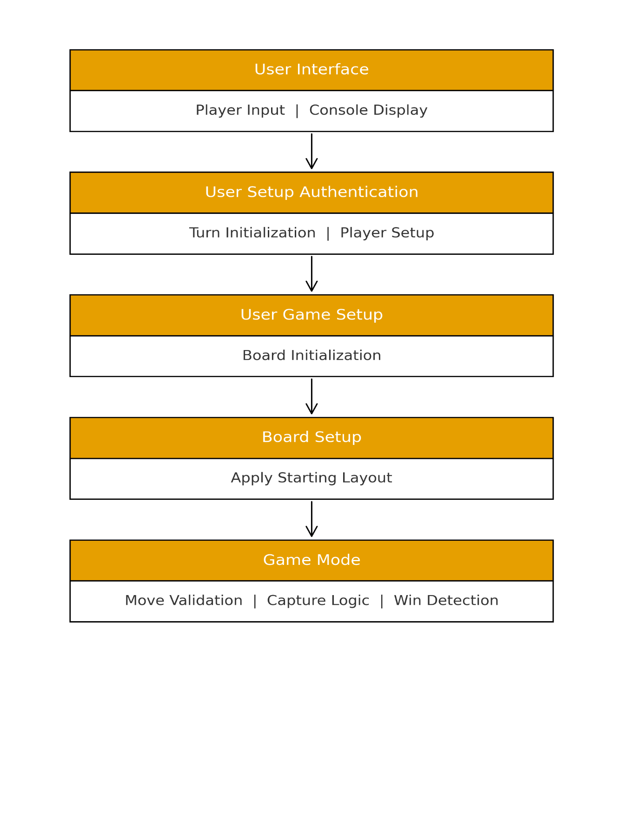

Use Case Model

UML Diagram(s)

Test Cases
- Game Round
  - Both players should be able to remove their respective pieces, but not to any invalid spots (i.e. to more than one square at a time, on top of another piece, or over an opponent without defeating them)
  - Both players should only be able to remove their respective pieces. Anything else is an error.
  - Opponents are eliminated when someone jumps over them, removing them from the board.
  - When one player reaches zero pieces, they will lose and the game will be over.
- Gameplay
The Board
The Board will be a large square grid, standard size for a Checkers board. Each Row and Column will be labelled with numbers and letters to allow the players to specify what piece will be moved and where to. There will be a check for invalid moves, preventing players from moving more than one space at a time. There will need to be another check to ensure a player can’t move their opponent’s pieces as well.

Summary
The goal of this is to recreate Checkers as a C++ program, playable within a terminal/CLI. This document contains both the broad ideas and finer details of the design for this Checkers program. This document also contains the Use Case scenarios, a UML diagram, Test Cases, and some details on the classes being used to make this system work. We will be using the latest version of C++ and employing principles taught to us by the SDEV 230 course. The test cases will help us ensure we keep this program at its fully intended functionality.

